RAG-Based Healthcare Query Assistant
AI-powered Multi-Agent Application for Healthcare Queries

1. INTRODUCTION
Healthcare organizations deal with a large amount of information in both structured and unstructured formats. Patient records are generally stored in databases, while hospital policies, privacy rules, billing procedures and safety guidelines are usually available as documents. For hospital staff, finding the required information can involve checking different systems and manually searching documents.
The RAG-Based Healthcare Query Assistant is developed to provide a single conversational interface for these tasks. Instead of requiring users to understand SQL or search through policy files, the application allows them to ask questions in plain English. An Orchestrator Agent identifies the type of question and routes it to the appropriate component.

1.1 Problem Statement
The main problem addressed by this project is the difficulty of accessing structured patient information and unstructured hospital knowledge through one simple interface. A conventional chatbot may not have access to current database values or organization-specific policies, while a database interface requires technical knowledge. The proposed system combines NLP-to-SQL, Retrieval-Augmented Generation and an LLM-based assistant to solve this problem.

1.2 Objectives
- Develop a conversational healthcare dashboard using Python and Streamlit.
- Allow users to query synthetic patient records using natural language.
- Retrieve relevant information from hospital policy documents using RAG.
- Design an orchestrator to route queries to different agents.
- Handle common general-health questions with useful, non-diagnostic guidance.
- Demonstrate the practical use of LLMs, embeddings, vector search and databases in one application.

1.3 Scope
The project is designed for academic demonstration. The patient dataset and policy documents are synthetic. The system is not intended for medical diagnosis, prescription or clinical decision-making.

2. SYSTEM REQUIREMENTS AND PROJECT OVERVIEW

2.1 Functional Requirements
- The user should be able to enter questions using natural language.
- The system should identify the type of query and select an appropriate processing route.
- Patient-data questions should be answered from the synthetic database.
- Hospital-policy questions should use retrieved document context.
- General health questions should receive suitable general information.
- The interface should display the final response in a simple conversational format.

2.2 Non-Functional Requirements
- The interface should be simple enough for non-technical users.
- Responses should be generated within a reasonable time.
- The application should keep API credentials separate from source code.
- The system should be modular so that individual agents can be modified independently.
- The application should clearly indicate that it is an academic/demo healthcare assistant.

2.3 Project Overview
The application has three main knowledge paths. The first path uses NLP-to-SQL to answer questions from patient records. The second path uses RAG to answer questions from hospital policy documents. The third path uses the general healthcare assistant for questions that do not depend on the project's structured or policy data.

2.4 Expected Users
The intended users for the demonstration are hospital staff or administrative users who need quick access to information. In the current academic version, the system uses synthetic information and therefore does not represent a production hospital environment.

3. SYSTEM DESIGN AND ARCHITECTURE

3.1 Multi-Agent Architecture
The system uses an Orchestrator Agent as the central routing component. The user only interacts with the main chat interface. Internally, the orchestrator decides whether the question is related to patient records, hospital policies or general healthcare information.
Component | Role
Streamlit UI | Provides the dashboard and chat interface.
Orchestrator Agent | Classifies the query and selects a processing route.
NLP-to-SQL Agent | Converts patient-data questions into read-only SQL queries.
RAG Agent | Retrieves relevant policy information using embeddings and FAISS.
General Assistant | Handles general healthcare questions.
SQLite | Stores the synthetic patient records.
FAISS | Stores and searches document embeddings.
Groq / Llama | Generates natural-language responses.

3.2 Overall Pipeline
User Query Orchestrator SQL Agent / RAG Agent / General Assistant Data Retrieval LLM Final Answer

3.3 NLP-to-SQL Pipeline
For a structured question such as “How many Diabetes patients are there?”, the SQL agent identifies the relevant fields and generates a read-only SELECT query. The query is executed against SQLite and the result is converted into a readable response.

3.4 RAG Pipeline
Policy documents are loaded from the project's data directory. They are divided into smaller chunks and converted into numerical embeddings using Sentence Transformers. FAISS stores these vectors and performs similarity search. The most relevant chunks are then supplied to the LLM as context.

3.5 General Healthcare Pipeline
Questions such as “I am having a cold, what should I do?” are treated as general healthcare questions. The assistant provides general supportive information and recovery tips while avoiding diagnosis and recommending professional care when appropriate.

4. IMPLEMENTATION

4.1 Technologies Used
Technology | Purpose
Python | Main programming language.
Streamlit | Healthcare dashboard and conversational UI.
Groq / Llama | LLM for natural-language processing and response generation.
FAISS | Vector similarity search for RAG.
Sentence Transformers | Text embeddings for policy documents.
SQLite | Structured patient-data storage.
Pandas | Dataset loading and processing.
Scikit-learn | Supporting/fallback retrieval.
Jupyter Notebook | Project walkthrough and experimentation.

4.2 Dataset
The project uses a synthetic healthcare dataset containing 55,500 patient records. The dataset includes information such as patient name, age, gender, blood type, medical condition, admission date, doctor, hospital, insurance provider, billing amount, room number, admission type, discharge date, medication and test results.

4.3 Policy Documents
The policy knowledge base contains synthetic documents related to HIPAA privacy, billing, FMLA leave, emergency admission and medication safety. These documents are used as the source material for the RAG agent.

4.4 Project Structure
healthcare_rag_assistant_v4.7/
├── README.md
├── How to Run!!!.txt
├── RUN-Healthcare Assistant.bat
├── .env.example
├── app.py
├── evaluate.py
├── requirements.txt
├── data/
├── src/
└── notebooks/

4.5 API Configuration
Groq is used as the LLM provider. The API key can be entered through the sidebar or configured using an environment variable. The actual API key should not be stored directly in the source code or uploaded to GitHub.

5. IMPLEMENTATION DETAILS AND USER INTERFACE

5.1 Application Interface
The final interface was designed as a healthcare dashboard rather than a technical AI demo. A dark green theme is used to give the application a consistent healthcare-oriented appearance. The main area is focused on conversation, while the sidebar contains configuration and a Daily Health Tip.
UI Section | Purpose
Healthcare Assistant Header | Introduces the main assistant.
Chat Interface | Allows users to ask questions in plain English.
Groq API Section | Accepts the API key required for LLM responses.
Daily Health Tip | Displays a rotating general wellness tip.
Recovery Tips | Provides additional supportive tips for suitable questions.
Disclaimer | Clarifies the academic/general-health nature of the application.

5.2 Example User Questions
Question | Expected Route
How many Diabetes patients are there? | NLP-to-SQL
Show patients prescribed Ibuprofen. | NLP-to-SQL
What does the medication safety policy say? | RAG
What is the hospital billing policy? | RAG
I am having a cold, what should I do? | General Assistant

5.3 Running the Project
The application can be run from VS Code using the command “streamlit run app.py”. The final project also contains “RUN-Healthcare Assistant.bat”, which provides a one-click method of starting the application. On the first run, the batch file creates the virtual environment and installs the required packages if they are not already available.

5.4 Security and Privacy Considerations
Only synthetic patient information is used in the current project. In a real healthcare application, authentication, authorization, encryption, audit logging, secure secret management and compliance controls would be necessary before handling real patient information.

6. TESTING, RESULTS & SNAPSHOTS

6.1 Functional Testing
Test Case | Route | Expected Result
How many Diabetes patients are there? | NLP-to-SQL | Patient count is returned.
Show patients prescribed Ibuprofen. | NLP-to-SQL | Matching patient records are returned.
What does medication safety policy say? | RAG | Relevant policy context is retrieved.
What is the hospital billing policy? | RAG | Billing policy information is returned.
I am having a cold, what should I do? | General Assistant | General guidance and recovery tips are provided.

6.2 Testing Approach
Testing was performed by asking representative questions from each processing route. The purpose was to verify that the orchestrator sends the question to the correct component and that the resulting response is understandable to a normal user.

6.3 Observed Results
The SQL route is suitable for questions that require exact information from patient records. The RAG route provides document-grounded answers for hospital policies. The general assistant provides a conversational response for common health questions such as cold, fever or cough-related queries.

6.4 RAG Evaluation
RAG quality can be evaluated using retrieval precision, retrieval recall, faithfulness and answer relevance. The project includes evaluate.py as a starting point for evaluation. A larger benchmark dataset can be added to obtain more meaningful quantitative results.

6.5 Limitations
- Natural-language questions can sometimes be ambiguous.
- LLM output depends on the selected model and API availability.
- The synthetic policy collection is smaller than a real hospital knowledge base.
- The system is not a clinical decision-support tool.
- A production version would require stronger security, access control and monitoring.

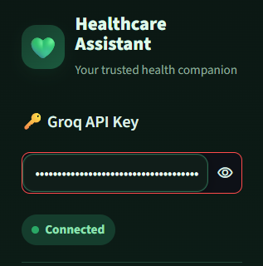

Api key Section

this will appear on the top left side of the dashboard where you can insert the API key

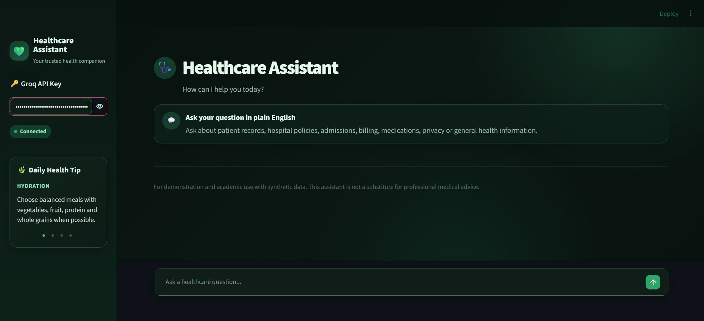
The Overall Dashboard
Over here the dashboard features the text box at the bottom where you can insert your query , on the bottom left we have a health tip box that updates you up daily with a new healthy living tip , it refreshes every 20 to 25 seconds .
Upon asking your Question the AI will answer you with the best possible solution or the best suitable query answer along with some additional tips or you can say advices to recover easily , quickly or things to avoid.

7. CONCLUSION AND FUTURE SCOPE

7.1 Conclusion
The RAG-Based Healthcare Query Assistant demonstrates how multiple AI and software engineering concepts can be combined into one practical application. The system uses an orchestrator to route questions, NLP-to-SQL for structured patient records, RAG for hospital policy documents and an LLM-based assistant for general healthcare questions.
The project also demonstrates why retrieval is useful when an application needs to answer questions from a specific set of documents. Instead of relying only on the language model's internal knowledge, the RAG agent retrieves relevant policy information and uses it as context for the response.
From a software engineering perspective, the project is modular because the database, SQL agent, RAG agent, router and user interface are separated into different components. This makes the system easier to test and extend.

7.2 Future Scope
- Add secure authentication and role-based access for hospital staff.
- Expand the policy knowledge base with additional verified documents.
- Improve SQL validation and add stronger protection against unsafe queries.
- Add conversation history with appropriate privacy controls.
- Create a larger evaluation benchmark for retrieval and answer quality.
- Add monitoring, audit logs and structured error handling.
- Deploy the application with secure environment-based secret management.
- Integrate approved healthcare knowledge sources with citations and verification.

7.3 Final Summary
Area | Implementation
Interface | Streamlit healthcare dashboard
Routing | Orchestrator Agent
Structured Data | NLP-to-SQL + SQLite
Unstructured Data | RAG + FAISS + policy documents
Embeddings | Sentence Transformers
LLM | Groq / Llama
Dataset | Synthetic healthcare records and policies
Purpose | Academic demonstration of a multi-agent healthcare assistant
Overall, the project provides a practical demonstration of how LLMs, retrieval, vector search and database querying can be combined to create a natural-language healthcare assistant. The current implementation provides a strong academic foundation that can be extended with stronger security, evaluation and verified healthcare data in future work.

